DNS | DHCP | ARP

DNS (Domain Name System) – takes the hostname we enter into a web browser (usually a URL) and translates it into the IP address of the actual remote server hosting the website.
A DNS Query is sent out asking for a translation of a given hostname to an IP address, a DNS Server answers the query, and the website is then loaded via its hosted server’s IP address. This is done in the background and is invisible to the end-user loading a webpage in a web browser.

DNS is also used to resolve internal hostnames as well, not just remote websites.
‘Host A’ needs the IP address of a device it only knows as ‘Host B’. The DNS query is received by the server, which then responds with the appropriate IP address for that host.
To complete this request ‘Host A’ also needs the MAC address of ‘Host B’.

ARP (Address Resolution Protocol) – finds the MAC address of a given Host provided it knows its IP address. There is no ARP Server, like there is a DNS Server. Rather, ARP uses a process where it broadcasts on L2, who is? (insert IP address), and if available on that broadcast domain, a host replies with its MAC address. This is then cached in the MAC address table, so the ARP process is not required to occur for that IP/Mac Combo again.

DHCP Fundamentals
Basic Components of a DHCP request
IP address: provide dynamically
Network Mask
DNS Server
Default Gateway

Message Types (DORA)
Discover
Offer
Request
Acknowledge
DHCPDISCOVER – aka a discover packet, broadcasts on 255.255.255.255 looking for a DHCP Server (request to discover DHCP server includes the source MAC address, obviously no IP as that is being requested)

DHCPOFFER – DHCP Offer – the response from the DHCP server upon receiving a discover request.
Contains: and IP address, network mask, a lease period, and the IP address of the DHCP server.

DHCP-Request – the response from a client device upon receiving the DHCP offer, indicating that the host is accepting of the DHCP offer parameters. The source IP of a request is still 0.0.0.0 with a destination of 255.255.255.255 (broadcast), the source MAC address is the MAC of the Host though. The request will indicate the IP address it is accepting (the same IP from the DHCP’s Server Offer.

DHCP Acknowledge – The Final Step. The server acknowledges receipt of the request from client and indicates that the IP is assigned. At this point the Client begins using the IP address.
Source: DHCP Server IP
Destination: 255.255.255.255 (Broadcast Address)
Dest MAC: MAC of client host.

What happens if there are multiple DHCP servers and multiple DHCP offers made to one client
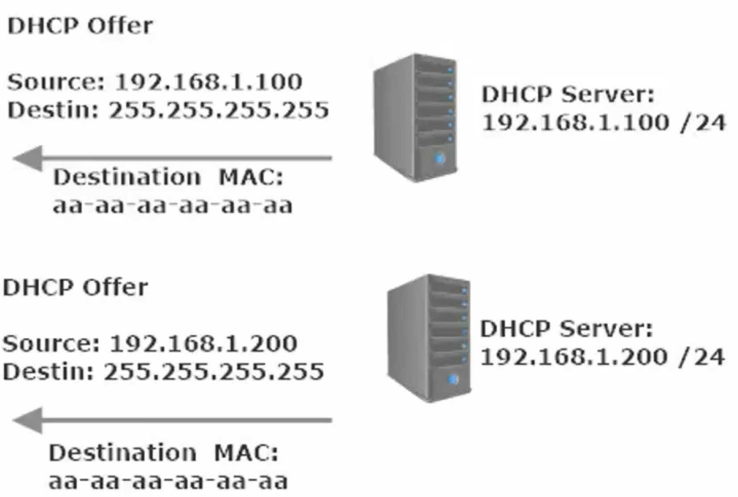
The first offer that is received is accepted

DHCP Relay Agent

What if there is a router between the host and the DHCP server?

A switch will not affect the forwarding of a Layer 3 broadcast, but a router will. As such, a DHCP Relay is required for DHCP to work on a client when a router is in between the DHCP server and DHCP Client.
A router will request a broadcast, accept a broadcast, but will not forward a broadcast (by default). DHCP uses broadcast Address on Layer 3 (255.255.255.255)
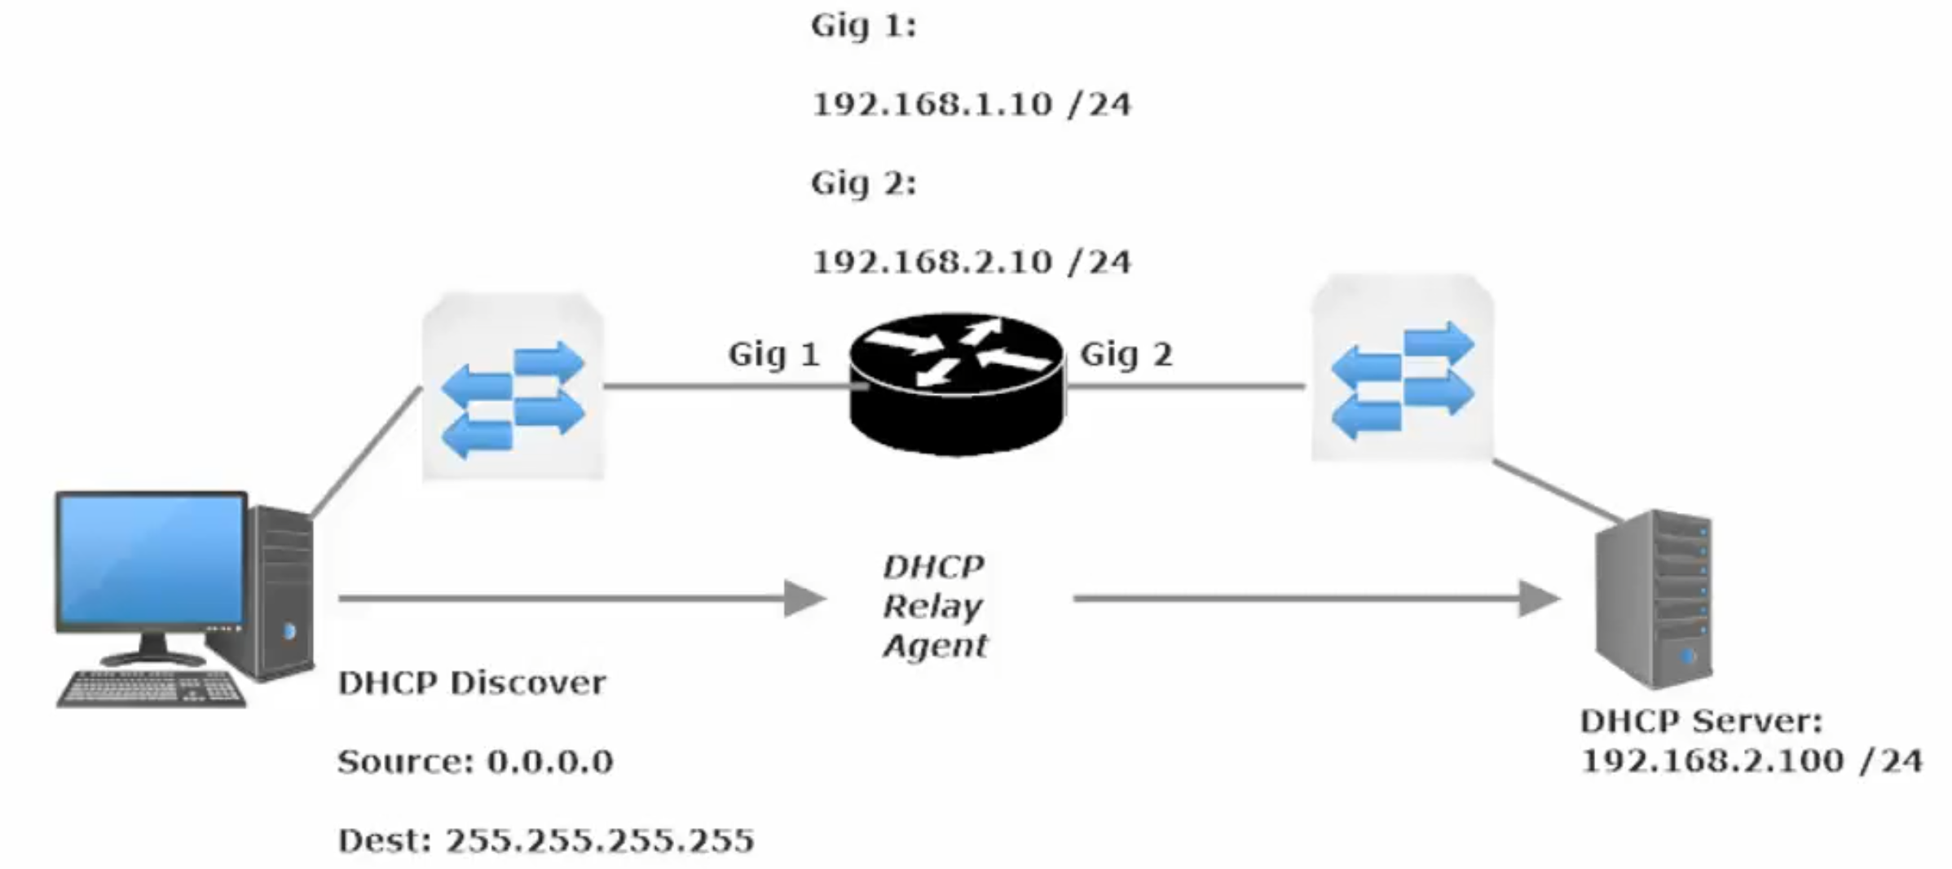

The DHCP relay must be configured on the router, using the ip-helper command.
Always configure the ip-helper address” on the interface that will be receiving DHCP discovers
Essentially the DHCP Relay Agent turns a DHCP discover broadcast into a Unicast

Commands related to the config above
R1(config)#int g0/0
R1(config-if)#ip helper-address <ip address of DHCP Server>
R1(config-if)#ip helper-address 192.168.2.251

Configuring a Cisco Router/Switch as a DHCP Server or Client

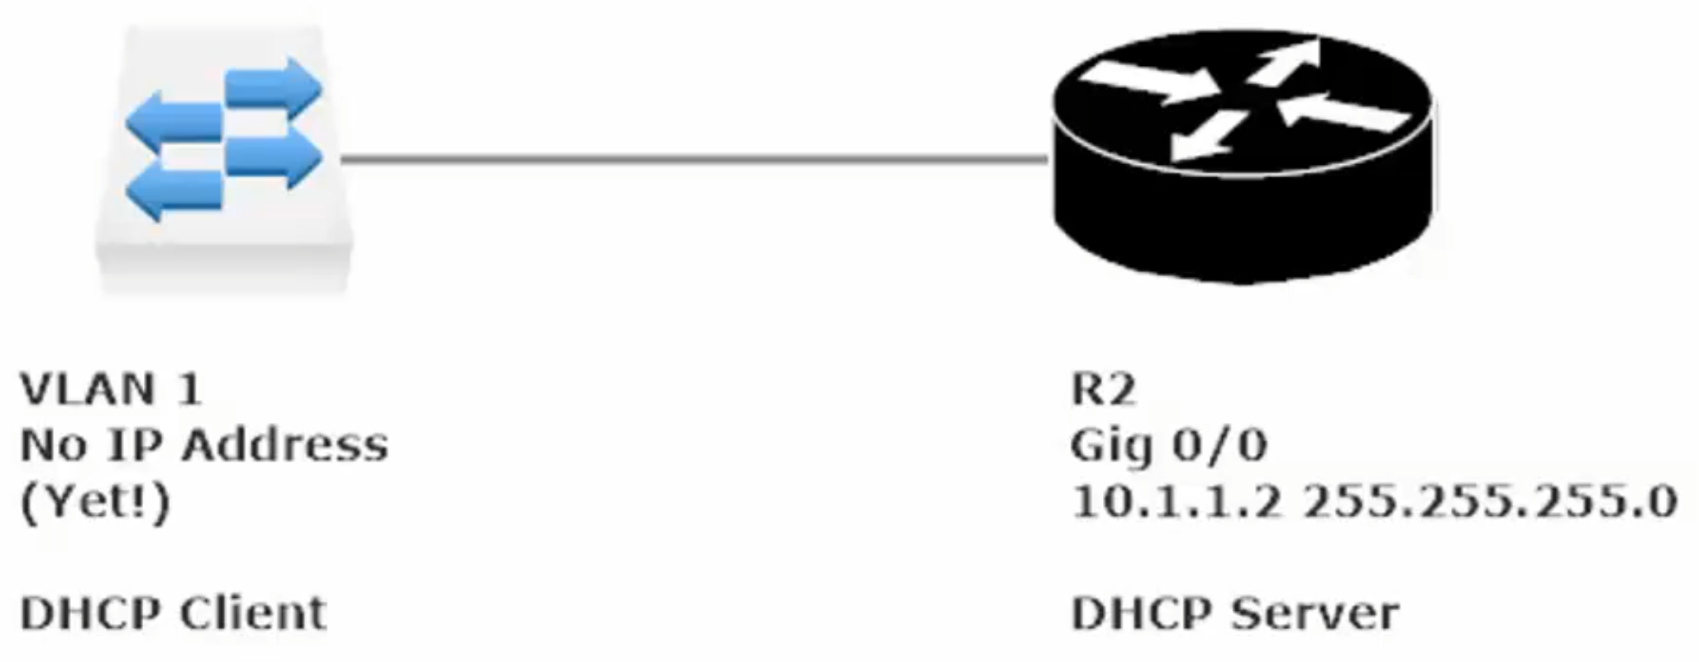

In this config the DHCP Server will be the router (R2) and the client will be the switch on VLAN 1

